EXPERIMENTS

NAME:BHARANI DHARAN
REG NO:192424141
COURSE CODE:DSA0602:DATA HANDLING AND VISUALIZATION

SET 2 – CUSTOMER FEEDBACK ANALYSIS

Customer ID | Age | Satisfaction Score
1 | 25 | 4
2 | 30 | 5
3 | 35 | 3
4 | 28 | 4
5 | 40 | 5

QUESTION 1
Create a histogram to represent the distribution of customer ages. Label the axes and title the chart.

AIM
To create a histogram in R to represent the distribution of customer ages.

PROCEDURE
- Create a vector containing customer ages.
- Use the hist() function.
- Give a suitable title to the histogram.
- Label the X-axis and Y-axis.
- Run the program and observe the histogram.
CODE

customer <- data.frame(
Customer_ID = c(1, 2, 3, 4, 5),
Age = c(25, 30, 35, 28, 40),
Satisfaction_Score = c(4, 5, 3, 4, 5)
)

hist(customer$Age,
main = "Distribution of Customer Ages",
xlab = "Age",
ylab = "Frequency")

OUTPUT

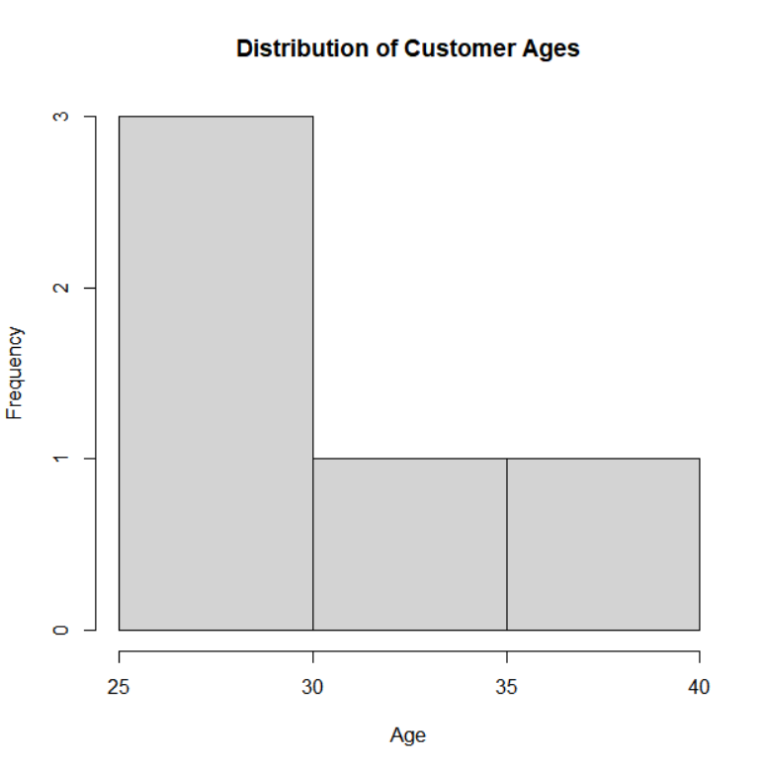

RESULT
Thus, the distribution of customer ages was successfully represented using a histogram in R.

QUESTION 2
Generate a pie chart to display the overall distribution of customer satisfaction scores. Include labels.

AIM
To create a pie chart in R to display the distribution of customer satisfaction scores.

PROCEDURE
- Create a vector containing satisfaction scores.
- Count the frequency of each satisfaction score.
- Use the pie() function.
- Add labels for each satisfaction score.
- Run the program and observe the pie chart.

CODE
customer <- data.frame(
Customer_ID = c(1, 2, 3, 4, 5),
Age = c(25, 30, 35, 28, 40),
Satisfaction_Score = c(4, 5, 3, 4, 5)
)

score <- table(customer$Satisfaction_Score)

pie(score,
labels = paste("Score", names(score)),
main = "Customer Satisfaction Distribution")

OUTPUT

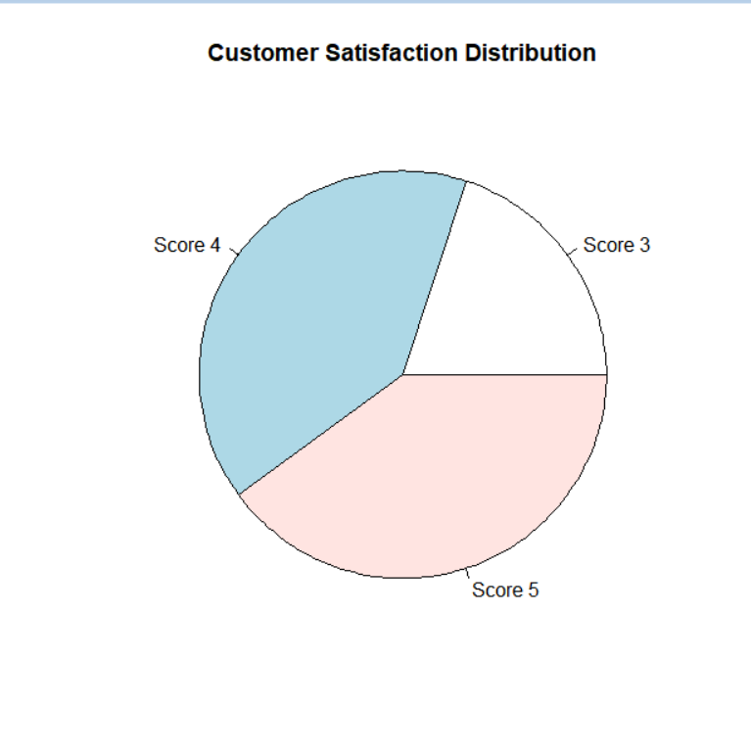

RESULT
Thus, the overall distribution of customer satisfaction scores was successfully represented using a pie chart in R.

QUESTION 3

Build a stacked bar chart to visualize the distribution of customer satisfaction scores by age group.

AIM
To create a stacked bar chart in R to visualize customer satisfaction scores according to age groups.

PROCEDURE
- Create vectors for customer age and satisfaction scores.
- Divide customers into age groups.
- Create a frequency table using table().
- Use barplot() to create a stacked bar chart.
- Add suitable labels and title.
- Run the program and observe the chart.

CODE

customer <- data.frame(
Customer_ID = c(1, 2, 3, 4, 5),
Age = c(25, 30, 35, 28, 40),
Satisfaction_Score = c(4, 5, 3, 4, 5)
)

customer$Age_Group <- cut(customer$Age,
breaks = c(20, 29, 39, 50),
labels = c("20-29", "30-39", "40-50"))

data <- table(customer$Age_Group,
customer$Satisfaction_Score)

barplot(data,
main = "Satisfaction Scores by Age Group",
xlab = "Age Group",
ylab = "Number of Customers",
legend.text = TRUE)

OUTPUT

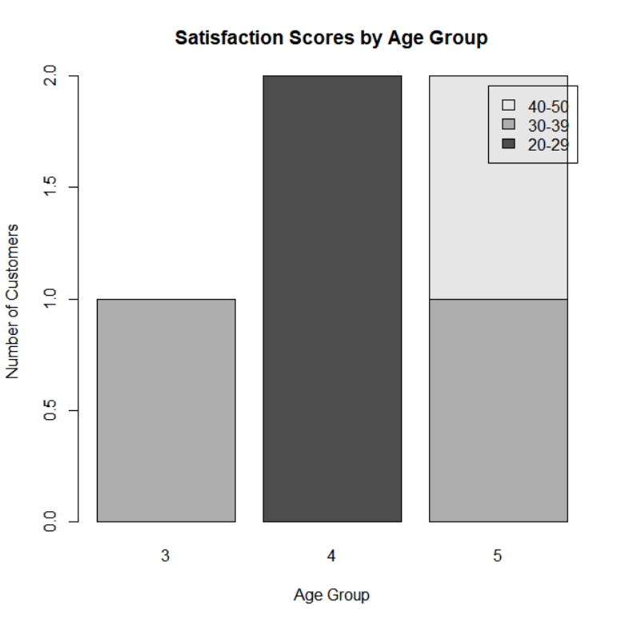

RESULT
Thus, the distribution of customer satisfaction scores by age group was successfully visualized using a stacked bar chart in R.

QUESTION 4

Develop a word cloud from open-ended customer feedback to identify prevalent customer sentiments.

AIM
To create a word cloud in R from customer feedback to identify frequently occurring words.

PROCEDURE
- Install and load the wordcloud package.
- Create sample customer feedback.
- Convert the feedback into words.
- Count the frequency of each word.
- Generate the word cloud using wordcloud().
- Observe the frequently occurring words.

CODE
library(wordcloud)
library(RColorBrewer)

feedback <- c(
"Good service and friendly staff",
"Excellent service and good experience",
"Friendly staff and good support",
"Excellent experience and fast service",
"Good support and friendly service"
)

words <- unlist(strsplit(tolower(feedback), " "))

word_count <- table(words)

wordcloud(names(word_count),
freq = word_count,
min.freq = 1,
random.order = FALSE,
colors = brewer.pal(8, "Dark2"))

OUTPUT



RESULT
Thus, the word cloud was successfully generated from customer feedback in R, helping identify the commonly occurring customer sentiment words.

